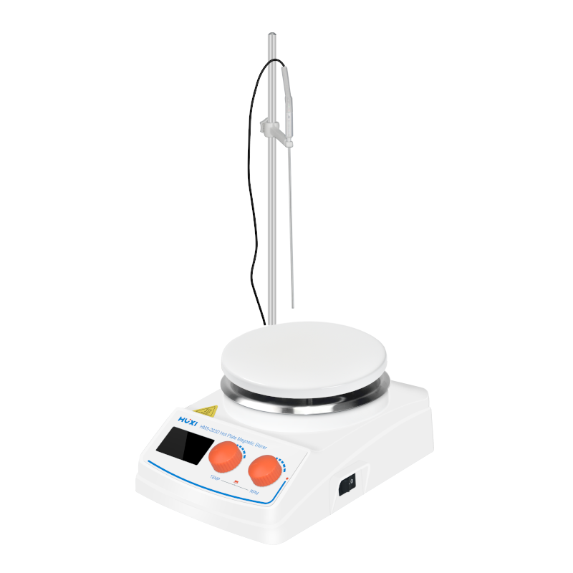

# **HMS-203D Hotplate Magnetic Stirrer**

# **Shaker**

# HT-S330 **Rotary Shaker**

**Application：**

HMS-203D Heated Magnetic Stirrer is mainly developed and designed for samples with heating requirements, suitable for stirring or heating stirring at the same time for liquids or solid-liquid mixtures whose viscosity is not very large. With the temperature control device, the temperature of the sample can be controlled and maintained according to the specific experimental requirements, helping the experimenter to set the experimental conditions, greatly improving the experimental repeatability of the possibility, widely used in colleges and universities, scientific research units, chemical industry, medicine and other fields.

**Main Features：**

* DC brushless motor, low noise, low maintenance and smooth running;
* Bottom with heat sink design, fast heat dissipation, effectively improve the continuous use time;
* When the sample temperature exceeds the set temperature of 5 ℃ when the instrument automatically open the alarm function, safer to use;
* Dual knob type operation button, can adjust the speed and time at the same time, convenient and quick;
* Built-in time setting function, setting range 0~9999 min, significantly improve the efficiency of work;
* The body is made of steel plate with plastic spraying, high strength, plasticity, heat resistance, good toughness and long service life.

**Technical Parameters：**

|  |  |
| --- | --- |
| Model | HMS-203D |
| Item No. | 1002051001 |
| Power Supply | AC200-240/50 |
| Noise db | ≤27 |
| Digital Display | Yes |
| Adjust Mode | Double knob |
| Display Mode | LCD |
| Display Type | Temperature ,speed and time |
| Alarm function | Yes |
| Heating function | Yes |
| Operation mode | Continuously/Time setting |
| Operation time | 0~9999min |
| Exterior Temperature sensor | PT100 |
| Motor type | DC brushless motor |
| Heating Power (W) | 350 |
| Speed Range(rpm) | 100-2000 |
| Speed Accuracy(rpm) | ±1 |
| Working plate material | Cast Aluminium Ceramic Coating |
| Working plate diameter(mm) | 135 |
| Max capacity(L) | 3 |
| Temperature control | RT-5~200℃ |
| Temperature control accuracy(℃) | ±1 |
| Heating plate temperature | ≤320 |
| Stirring bars range | 5~40 |
| Allowable ambient humidity(%) | 80 |
| Instrument Size(mm) | 225*145*103 |
| Packing Size(mm) | 315*270*175 |
| GW(kg) | 3.5 |
| NW(kg) | 3 |
| Shell protection class | IP21 |